Eli Sobylak

Worked with Alex Bott

Lab 6

Blackbox testing:

**fn1**

To call I used the code;

public class GuessMee

{

public static void main(String[] args )

{

int xx = 0;

do {

xx = xx + xx + 1;

System.out.println(xx + " \t" + GuessMe.fn1(xx));

} while (xx>0);

}

}

Which produced the results;

1 -2 X-3

X*2-1

3 0

7 4

15 12

31 28

63 60

127 124

255 252

511 508

1023 1020

2047 2044

4095 4092

8191 8188

16383 16380

32767 32764

65535 65532

131071 131068

262143 262140

524287 524284

1048575 1048572

2097151 2097148

4194303 4194300

8388607 8388604

16777215 16777212

33554431 33554428

67108863 67108860

134217727 134217724

268435455 268435452

536870911 536870908

1073741823 1073741820

2147483647 2147483644

-1 -4

Numbers reach the end of range that can be expressed by 32 bits, and then rolls over.

**fn2**

The output I got was

1 2 X*2

X*2-1

3 6

7 14

15 30

31 62

63 126

127 254

255 510

511 1022

1023 2046

2047 4094

4095 8190

8191 16382

16383 32766

32767 65534

65535 131070

131071 262142

262143 524286

524287 1048574

1048575 2097150

2097151 4194302

4194303 8388606

8388607 16777214

16777215 33554430

33554431 67108862

67108863 134217726

134217727 268435454

268435455 536870910

536870911 1073741822

1073741823 2147483646

**2147483647 -2

-1 -2

** The number identified here is the largest value this function generates before rolling over.

**Fn3**

1 2 X*2+4

X*2+1

3 8

7 20

15 44

31 92

63 188

127 380

255 764

511 1532

1023 3068

2047 6140

4095 12284

8191 24572

16383 49148

32767 98300

65535 196604

131071 393212

262143 786428

524287 1572860

1048575 3145724

2097151 6291452

4194303 12582908

8388607 25165820

16777215 50331644

33554431 100663292

67108863 201326588

134217727 402653180

268435455 805306364

536870911 1610612732

1073741823 -1073741828

2147483647 2147483644

-1 -4

Got bored and decided to move to drawing graphics!!

I manipulated the code we were given for a little while and tried to see what I could get it to do. After looking up primitive graphics for java online, I found out what all the values each shape was passed ex. page.fillArc(100, 40, 70, 70, 0, 75);

After playing around with it for a while this is what I came up with;

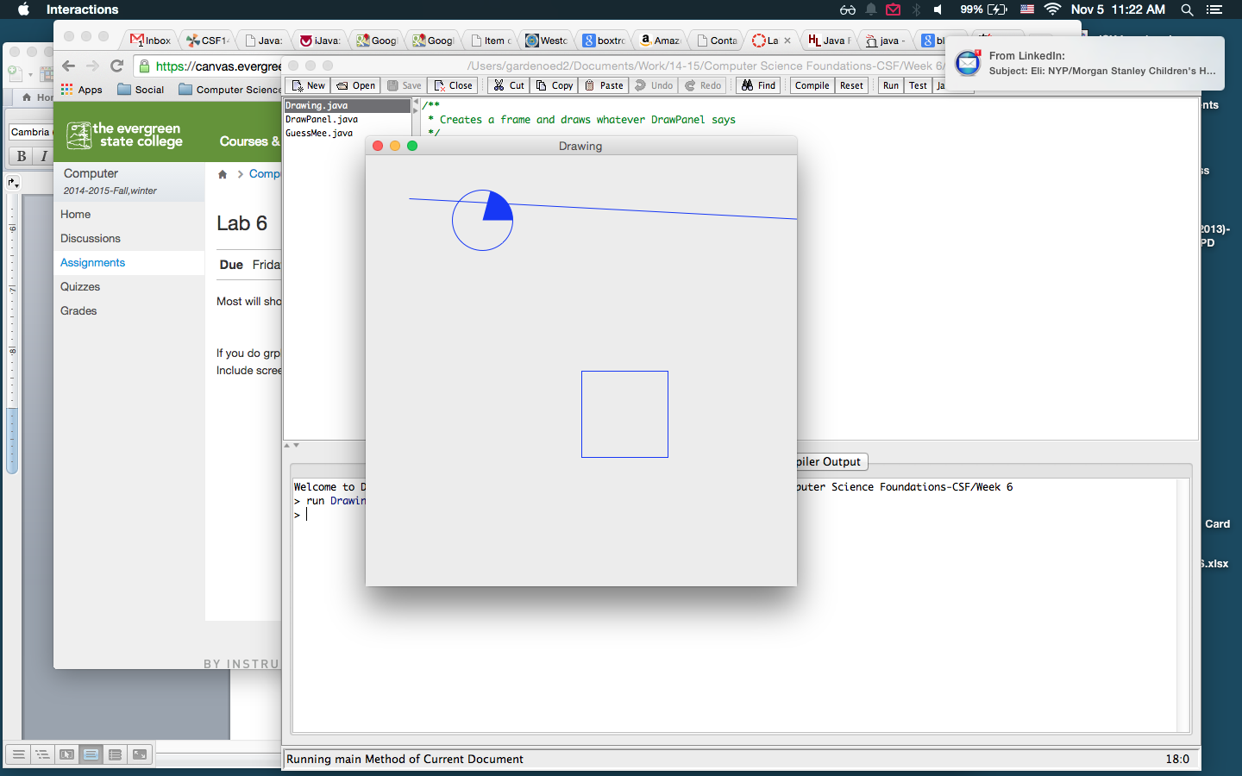

I think next, I would like to learn how to incorporate for loops in the Jpanel code so that shapes can move about the page.